Paper Title (12Pt)

(11 Pt) First Author¹,
Archaeological Survey of India,
Raipur Circle, Raipur, Chhattisgarh, India

Second author2,
Kalyan Post Graduate College,
Bhilainagar (Durg), Chhattisgarh, India

Third Author³,
Kalyan Post Graduate College,
Bhilainagar (Durg), Chhattisgarh, India

Fourth Author⁴
Government Post Graduate Science College,
Durg, Chhattisgarh, India

Abstract

Fungi are complex communities of microorganisms that have deteriorating effects on historic sandstone monuments. This myco-ecological study was specifically made to examine the diversity of fungi associated with deteriorated monuments sites. In the present investigation, 10 samples were collected from various portions of deteriorating sites of Kala Dera-II temple at Manwal. Six fungal species were isolated from deteriorated monument sites are reported in this paper. Among these, Fusarium (Schlechtendahl) fungal species has been found having maximum frequency.

Keywords: First Keyword, Second Keyword, Third Keyword,

INTRODUCTION
Kala Dera- II temple is assignable to circa 10th-11th century AD (S.A., 2012) and is located in Udhampur District of Jammu & Kashmir state of India. It is Saptratha on plan externally. It is built on a raised platform approached by a flight of steps on the east. The roof of the mandapa was supported on four fluted columns surmounted capitals. On the west side there is a makaramukha pranala through which the water used to flow into a small rectangular cistern is carved out of a single block. Besides the principal entrance, facing the central aisles, it has two smaller entrances at the rear. The figure on the jambs of the door and the porch are now defaced. The sikhara is intact on the western side and externally the temple is adorned with plain projecting niches and offsets bearing carving. On the south-east corner, basements of the other two shrines are positioned. The sandstone surfaces of various sites of the temple monument are continuously affected by physical, chemical and biological agents. Among biological agents, microorganisms are responsible for the destruction of cultural heritage (Bock and Sand, 1993; Ciferri, 1999). They cause damages on the stone surfaces by formation of biofilms, chemical reactions with the substrate, physical penetration in to the substrate as well as pigment production. Numerous studies have dealt with establishing the role of biological agents in the stone deterioration (Pochon, and Jaton, 1968; May et al., 1993). During recent decades there has been a growing concern about deterioration of historic building by chemical and physical factors as well as microbial population growth on the surface of stone. The microbial growth on the surface of stone play an important role in this deterioration process (Suihko,2007;Gupta, et.al.2015).
The weathering and decay of cultural heritage is a complex process, which is caused by the interaction of many physical, chemical and biological agents. The different biological deteriogens such as bacteria, algae, cyanobacteria, bryophytes, mosses, fungi, insects, rodents, birds and human beings play a momentous role in the decay of historical monuments. The biological growth of microorganisms can cause staining, cracking, powdering, disfigurement and displacement of building material, which leads to the permanent loss of stone monuments. Such aesthetic damage is accompanied by the transformation of the chemical and mechanical properties of stone material and this causes the formation of surface patinas of different colors (Wainwright INM (1986); Griffin et. al. 1991; Muhammad Farooq et.al., 2015). Among different biological agents, fungi play more dangerous role in the bio-deterioration of stone monuments because of their complex metabolic activities on stone surface (Muhammad Farooq et.al. ,2015;Gupta, et.al.2015).

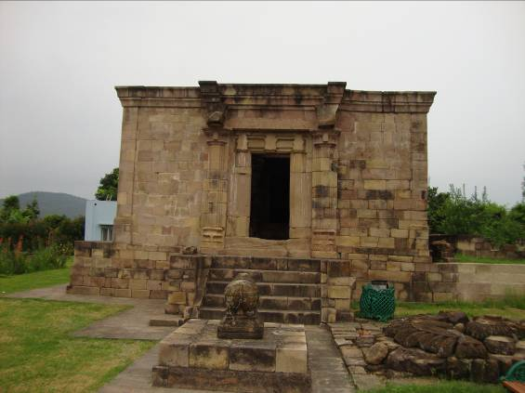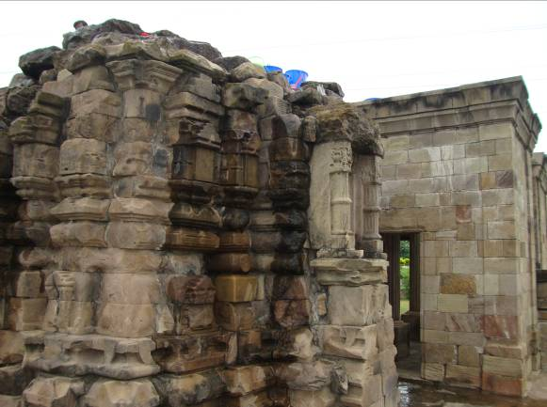
a b
Fig -1: Kala Dera – II temple of Manwal a- Front view b- lateral view
There are numerous monuments in Udhampur District of Jammu & Kashmir state. One of such monument, the kala Dera – II temple (Fig-1). Stone surfaces of this temple are continuously exposed to physical, chemical and biological degradation. Often, physical, chemical, and biological agents act in co-association, ranging from synergistic to antagonistic, leading to the deterioration, ultimately affecting the stone durability.The aim of this work is to study the micro fungi community on monuments by using myco-ecological parameters and microscope observations in order to evaluate the importance value index and damage caused by fungal species.

Conservation Issues

The Kala Dera-II temple was built of sand stone, which is porous in nature. The surface deposits seem to be very old due to the formation of secondary dull green pale white lichens, which are present all over the stone surface. Due to these deposits, the aesthetic beauty of the temple is seriously affected. From a scientific point of view, these depositions are very harmful for the health of the stone surface, because these micro organisms secrete an acid that dissolves the sand stone (Gupta and Sharma, 2011; Gupta et. al.,2016).

MATERIAL AND METHODS

a- Sampling and Isolation of fungi
A total of 10 Samples were collected from various locations of Kala Dera-II temple of Manwal of Udhampur district of J & K State and brought to the laboratory under aseptic conditions. The isolation of micro- organisms was done by culturing the samples and by direct incubation of samples in moist chamber (Fig-2). The purified fungal cultures were identified by using mycological techniques and were compared with the available authentic literature, reviews and mycological manuals (Alexopoulus, 1978; Barnett & Hunter, 1987; Ellis, 1976 and Gilman, 1995;Gupta, et.al.2015).

b-Calculations
Various myco-ecological parameters have been calculated using the following formulae:

Number of plates in which specific organism occurred
Frequency (F %) = ---------------------------------------------------------------------X 100
Total number of plates examined

Total number of colonies of specific organism
Density (D) = ---------------------------------------------------------------------
Total number of plates examined

Total number of colonies of specific organism
Abundance (Ab) = ---------------------------------------------------------------------
Number of plates in which specific organism occurred

OBSERVATION TABLE - 1
Isolated fungi | Culture plates |  |  |  |  |  |  |  |  |  | F % | D | Ab
 | P1 | P2 | P3 | P4 | P5 | P6 | P7 | P8 | P9 | P10
Aspergillus sydowi (Thom and Church.) | 2 | - | 1 | - | 1 | 1 | - | 1 | - | - | 50 | 0.60 | 1.20
Aspergillus flavus (Link.) | - | - | 4 | 3 | - | - | - | - | 2 | - | 30 | 0.90 | 3.00
Aspergillus niger (Tieghem.) | - | 5 | 2 | - | 8 | - | 6 | - | - | 4 | 50 | 2.50 | 5.00
Fusarium oxysporium (Schlechtendahl.) | 1 | 1 | - | 1 | - | 1 | - | 1 | 1 | 1 | 70 | 0.70 | 1.00
Penicillium sanguifluum (Sopp.) | 1 | 2 | - | 3 | - | - | - | - | 2 | - | 40 | 0.80 | 2.00
Bipolaris sorokinianum (Schoemaker.) | - | 3 | 2 | - | - | 3 | - | 5 | - | 1 | 50 | 1.40 | 2.80

C -Removal of Dust and Dirt Accretion
Measures were taken by the Archaeological Survey of India for the removal of dust and dirt accretion to keep the stone in neutral pH and to preserve and strengthen the stone by soft brushing. The moss, fungi and lichen were removed by applying 2-3% solution of ammonia with non ionic detergent in water and by scrubbing with a nylon brush. To stop further growth of micro vegetation, 2% aq. solution of sodium pentachlorophenate was applied on the clean, dried surface. The brittleness and powdering of stones were preserved by the application (brushing and impregnation till saturation) of an ethyl silicate based coating material, which forms a glass like silica gel binder (SiO2 aq.) with release of ethanol (by evaporation) as byproduct. Noteworthy is that the intake of stone strengthener materials was comparatively higher in the case of damaged and pulverized stones. That can be attributed to the presence of more pores for penetration. The coating of stone strengthener was applied on the deteriorated and flaky stone surface by simple brushing and impregnation till saturation (Gupta and Sharma, 2011; Gupta et. al.,2016).

d- Preservation Solutions

It is essential that the preservation solution applied on the monuments be of good quality. It should be colorless and transparent and must not turn yellow or become colored with age, but should be fairly stable for long period of time. It should also offer reasonable protection to the monument against moisture and its film should be hard and strong enough to protect the stone surface from damaging accretions. Therefore, for the preservation of the Kala Dera-II temple silane-siloxane based compound (Wacker BS-290) was chosen, which was diluted with Mineral turpentine oil in a ratio of 1:16 and applied on the monument by soft painting brush. By using MTO as a solvent slight temporary darkening appears but preserved surface gradually get their original appearance because of slow evaporation of solvent. This compound is water proof and stops water from settling on the stone surface (Gupta and Sharma, 2011; Gupta et. al.,2016).

RESULTS AND DISCUSSION

During screening for search of mycoflora, total six species of fungal organisms were isolated from Kala Dera-II temple. Composite result indicate that in all the ten (10) plates were mainly dominated Fusarium oxysporum due to their high percentage frequency followed by Aspergillus sydowi, Aspergillus niger and Bipolaris sorokinianum in the study areas. Some of the fungal species are confined to particular area i.e. Aspergillus sp., Rhizopus nodosus and Chaetomium globossum. These confinements of fungal species depend on environmental conditions of the area, which varies from geographical area to area (Salvadori, 2000). In the present study Fusarium species is found to have most commonly populated on almost all the sites of this historic monuments (Gupta, et.al.2015).
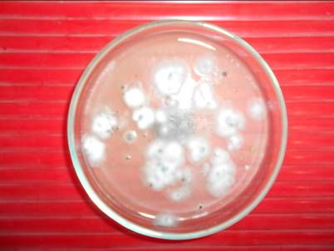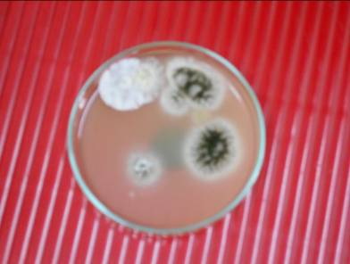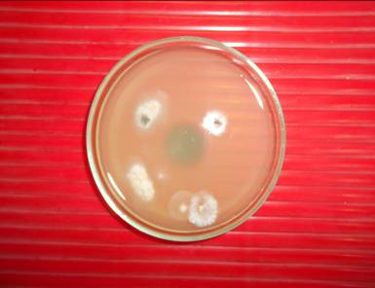
a b c
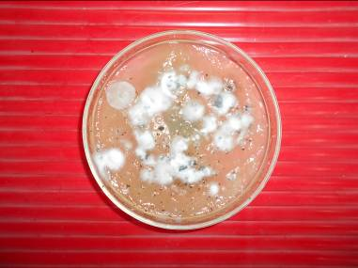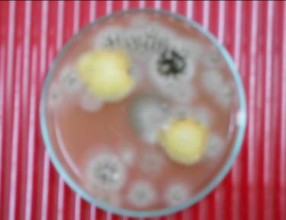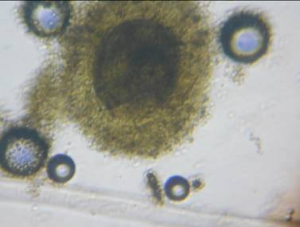
d e f
Fig-2: a, b. c. d. e and f: View of growth of fungal species on culture media in Petri plate

The composition of fungal organism has variation which depends upon biochemical nature of host, degree of competition between the fungal organisms and the prevailing environmental conditions. The frequency and relative frequency are directly or indirectly correlated with meteorological data and climatic conditions (Chandel, 1990;Gupta, et.al.2015).
In each fungal community all the species are not equally important. There are relatively only few of these, which determine the nature of the community (Simpson, 1949). These few species exert a major controlling influence on the community and also play important role in deterioration of various substrates.It has also been shown in the laboratory that fungal species such as Aspergillus niger were able to solubilize powdered stone and chelate various minerals in a rich glucose medium because they produce organic acids such as gluconic, citric, and oxalic acids (Lapidi & Schipa, 1973). The toxic metabolites produced by various species of fungal organisms function as chelating agents that can leach metallic cations, such as Iron, Magnesium etc from the stone surface. Laboratory experiments have demonstrated that basic rocks are more susceptible to fungal attack than acidic rocks. In the present study Aspergillus are the most common species found in the sites. Aspergillus niger released certain metal ions from the rock samples (Boyle & Voight, 1973;Gupta, et.al.2015).

ACKNOWLEDGEMENT

Authors are grateful to Principal Kalyan P. G. College, Bhilainagar for providing laboratory facilities for identification of fungal species and Superintending Archaeologist, Srinagar Circle, Jammu for his support for providing historical and archeological information related to the monument under study.

REFERENCE

A. A. Lapidi, and G. Schipa, (1973): Some aspects of the growth of chemotrophic and heterotrophic bacteria from decayed stone. In: Proceedings of the 5th International Congress on deterioration and conservation of stone. (Ed) G.Felix Lausanre, Switzerland. pp. 633-640,
Alexopoulos, C.J. (1978): Introductory mycology (2nd Ed.). Wiley Estern Ltd. New Delhi, Banglore, Bombay.
Barnett, H.C. and B. Barry Hunter (1987): Illustrated genera of important fungi. Macmillan Publishing Company. New York and Collier. Macmillon Publishers, London.
Bock E. and Sand W., (1993): The microbiology of masonry biodeterioration, J. Appl. Bacteriol., 74, pp. 503-514.
Boyle, J. R. and G. K. Voight (1973): Biological weathering of silicate minerals. Implications for tree nutrition and soil genesis. Plant and Soil. 38: 191-201.
Chandel, D.S. (1990): Studies of Phylloplane interaction of fungi from Soybean and Pigeon pea. Ph.D. Thesis. Pt. Ravishankar University, Raipur.
Ciferri O., (1999): Microbial degradation of paintings, Appl. Environ. Microbiol. 65, pp. 879-885.
Ellis, B.M. (1976) : More Dematiaceous Hyphomycetes. CMI, Kew, England.
Gilman, C. Joseph (1995) : A Manual of Soil Fungi. Print well publication, Jaipur (India).
Griffin PS, Indicator N, Koestler RJ (1991): The biodeterioration of stone: A Review of deterioration mechanisms, conservation case histories and treatment. International Biodeterioration 28(1-4): 187-207.
Gupta, S.P. and Sharma, K.(2011): “Biodeterioration and Conservation of Sita Devi Temple,
Deorbija, Chhattisgarh, India” INT J CONSERV SCI 2, 2: 89-94, APR-JUN 2011.
Gupta S. P., D. N. Sharma, G. K. Chandrol, and G.N. Shrivastava (2015): Indexing of fungal flora on deteriorating sandstone monuments with special reference to Kala Dera-II temple at Manwal (Jammu and Kashmir state, India), International Journal of Innovation Sciences and Research,4(8):374-376.
Gupta S. P., D. N. Sharma, G. K. Chandrol, Rohit Misra and D. K. Minj (2016): Fungal deterioration of sandstone structure and their scientific presevation with reference to historical monument Kala Dera-I temple of Jammu& Kashmir state (India), International Journal of Research in Engineering and Applied Sciences, 6(6):1-9.
May E., Lewis F. J., Pereira S., Tayler S., Seaward M. R. D. and Allsopp D., (1993): Microbial deterioration of building stone: A review. Biodeterioration Abstracts, 7, pp. 109-123.
Muhammad Farooq, Mukhtiar Hassan and Farzana Gull (2015): Mycobial Deterioration of Stone Monuments of Dharmarajika, Taxila. Journal of Microbiology & Experimentation 2(1):1-6.
Pochon J. and Jaton C., (1968): Biological factors in the alteration of stone, In: A. H. Wolters, CC Elphick, Eds., Biodeterioration of Materials, Elsevier, Amsterdam, pp. 258-268.
Salvadori, Ornella O. (2000): Characterization of endolithic communities of stone monuments and natural outcrops. Kluwer Academic Publishers, New York. pp. 89-101.
Simpson E.H. (1949): Measurement of diversity. Nature, pp. 163 – 688.
Suihko L. M., Alakomi L. H., Gorbushina A. A., Fortune I. and Marquardt S. M., (2007): Characterization of aerobic bacterial and fungal microbiota on surfaces of historic Scottish monuments. Syst. Appl. Microbiol., 30, pp. 494-508.
Superintending Archaeologist (2012): Centrally protected monuments of Jammu region, Archaeological Survey of India, Srinagar Circle (J & K).
Wainwright INM (1986): Lichen removal from an engraved memorial to Walt Whitman. Association for preservation Technology Bulletin 18(4): 46-51.

Biography of Authors (10pt)

First author’s  Photo (3x4cm) | The author of education background / previous publication / unpublished publication / a work (9 pt)
Second author’s photo(3x4cm) | The author of education background / previous publication / unpublished publication / a work (9 pt)
Third author’s photo(3x4cm) | The author of education background / previous publication / unpublished publication / a work (9 pt)
Fourth author’s photo(3x4cm) | The author of education background / previous publication / unpublished publication / a work (9 pt)

